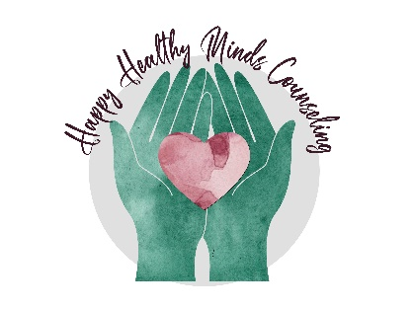
Happy Healthy Minds Counseling
Newsletter -June 2020

You are not alone during this Pandemic
By Cynthia (Cindy) Silver, MA, Registered Mental Health Counseling Intern

If you are feeling more stressed than ever due to COVID-19, you are not alone. Experts report that the pandemic is causing a significant rise in mental health problems. Even Olympic swim champion Michael Phelps recently reported: “This is the most overwhelmed I’ve ever felt.” It is not unusual to be experiencing a wide range of feelings such as sadness, loneliness, anger, confusion, fatigue, and hopelessness during this time of uncertainty.

Here are some tips to help manage your feelings to keep yourself mentally healthy:

- Accept your feelings. Do not label your feelings as good or bad.
- Be kind to yourself by not engaging in self-critical thoughts.
- Accept the reality of the situation by acknowledging that although stressful, there may be positive things to learn from this experience. Then, focus as much as you can on the positive.
- Create a daily journal to write about your feelings and experiences looking for patterns of thoughts and behaviors that cause distress.
- Devise a new routine. Keeping to a routine provides you with a feeling of control.
- Look for a silver lining to the situation. For example - I am using this period of isolation to reflect and get to know myself.
- Try something new such as meditation, online yoga, or a new recipe.
- Stay connected as much as possible through phone calls, social media and online get togethers such as Facetime or Zoom.
- Practice self-care by doing something every day to treat yourself like reading a book, taking a bath, or having a cup of tea.

However, if you are still feeling overwhelmed, therapy can help. Happy Healthy Minds Counseling is accepting new clients. Call today 813-365-9166 to schedule your appointment.

Cindy Silver recently joined Happy Healthy Minds Counseling and specializes in treating Adults with transitional life issues, relationship issues, anxiety, depression & grief. She is currently taking new clients via telehealth.

June is also National Candy Month: A few random candy facts

- William James Morrison who invented cotton candy was a dentist.
- The Three Musketeers candy bars got their name because each bar originally came as three pieces, each with a different flavor, vanilla, strawberry, and chocolate.
- Snickers, one of the most popular candy bars today, was named after a horse.
- Germans consume almost twice as much candy as Americans
- Bubble Gum was traditionally pink because that was the only dye color available when it was invented.

What’s New at HHMC

- New Clinician – We have added another clinician Erin Richard, soon to be LCSW, who specializes in seeing clients who have experienced trauma and helps them create a “new normal.” She is accepting new clients via telehealth and in the St. Pete office. See the website for her full bio.
- Grace Willms, LCSW is also accepting new clients in the St. Pete office and telehealth. She specializes in children, adolescents, and young adults.
- New offices- The St. Pete office has expanded to 2 offices (one for children & one for adults) in the same building (Suite 116 & 118). A Tampa (Westchase area) office is coming soon. More details coming soon.
- New Insurance paneling - We should be approved for Aetna Insurance any day now.

Important Dates

- June – LGBTQ Pride Month, Men’s Health Month, National Candy month
- June 20 – June Solstice
- June 21 – Father’s Day
- July 3 – Independence Day Observed
- July 4 – Independence Day
- July 15 – Tax Day

Happy Healthy Minds Counseling will be closed Friday, July 3^{rd,} and Saturday July 4th in observance of Independence Day!

Happy Father’s Day!

Wishing you all a Happy Summer!

